Running the mgb… notebooks
Open your Juypter Lab
Once open click: Start a new Terminal Session

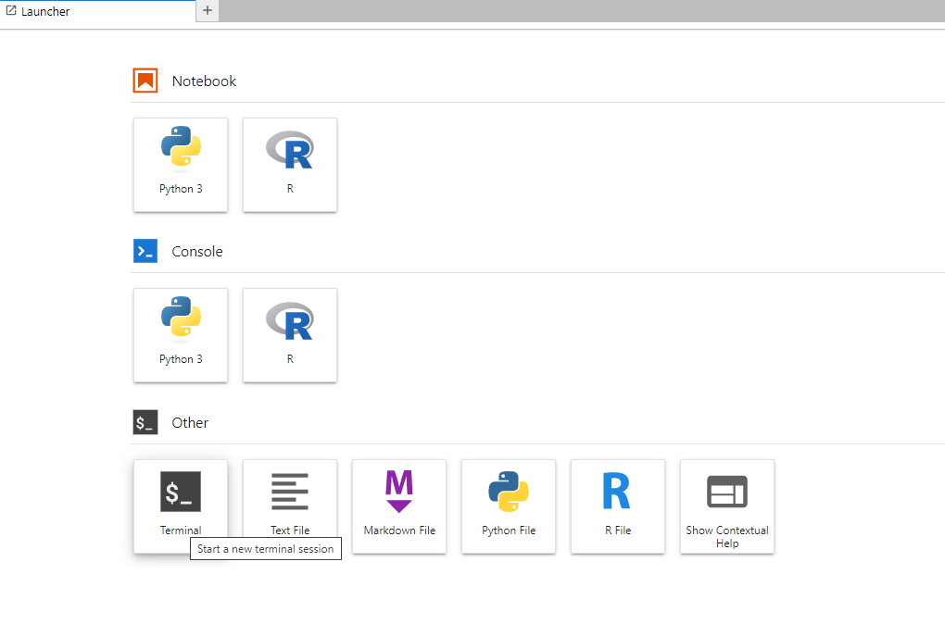
Once here type in : gcloud auth application-default login

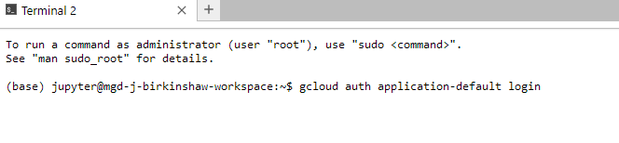
When prompted type Y
The following will appear :
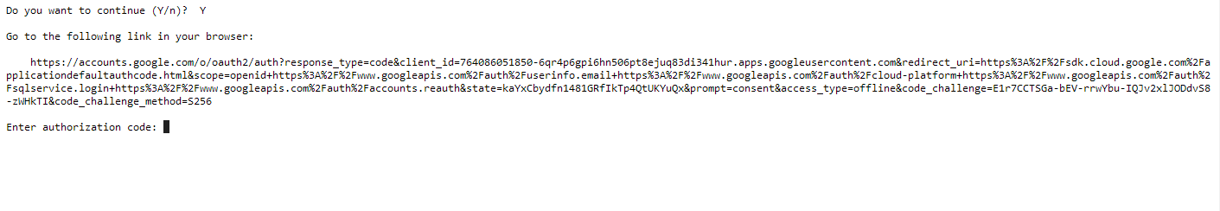
Select and copy that url and go you your browser, paste it into the address bar at the top. You may them be presented with a window like this:
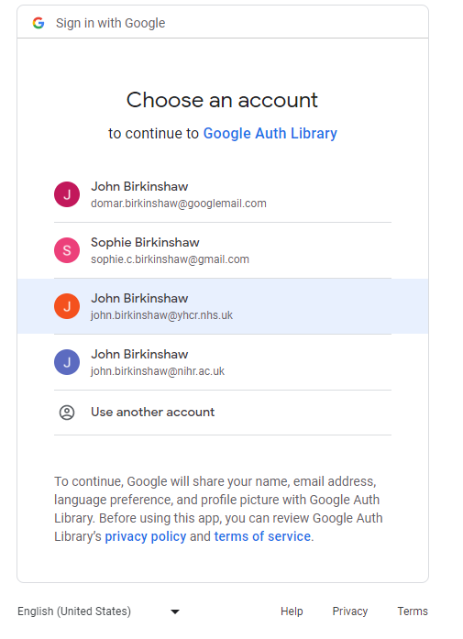
select the yhcr.nhs.uk account. This will then appear:
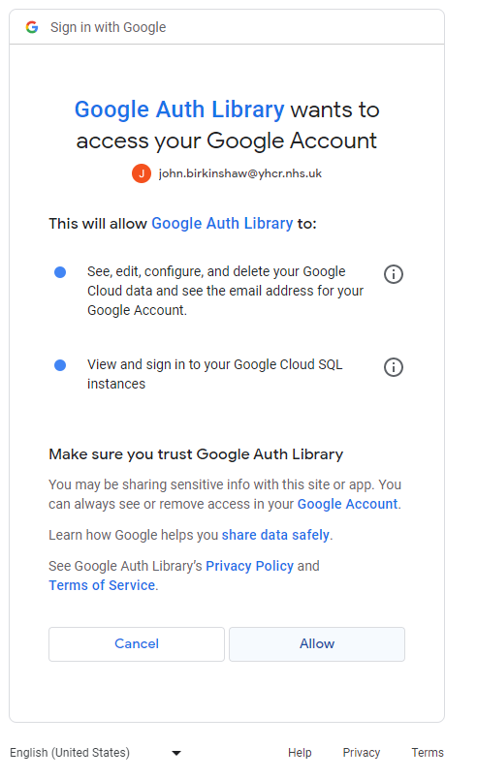
Click allow.
This will appear :

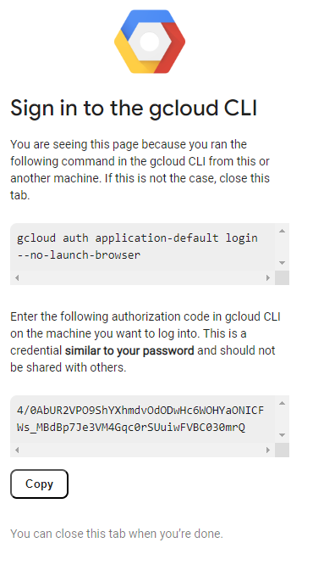
Click Copy and go back to juypterlab to your terminal and paste (ctrl-v) that code in :
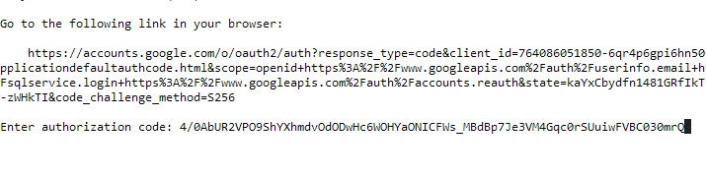
And hit enter(return) , then type in : export GOOGLE_APPLICATION_CREDENTIALS="[PATH]"
You can then open a R script as normal. BUT you must ensure that the first two lines of code are:
library(bigrquery)
bq_auth()
in an r script to set up the authentication properly.

For Python scripts open a terminal and run :
pip install git+https://github.com/googleapis/python-bigquery-pandas.git

After completing the above.

